

22f-3104

DB Lab 02



February 9, 2024

Fast cfd campus

**Task no 1:**

**1. Create a new blank database in MS Access**

**2. Create a table with following fields:**

**a. Input expenses with details (ID, date, category (food, transportation,**

**entertainment, gas bills), amount, description), use appropriate field type.**

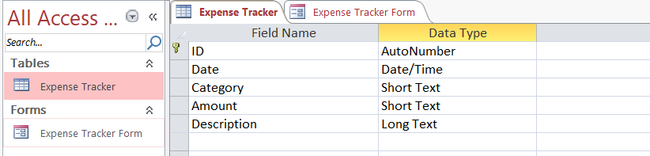

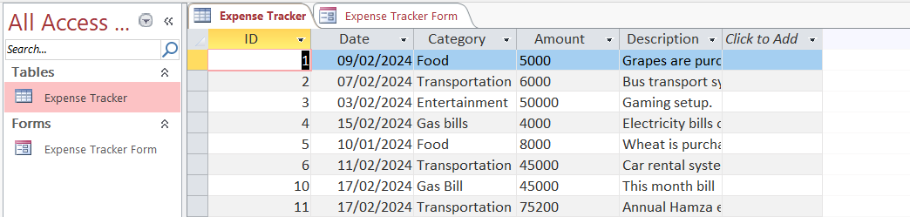

**Task no 2:**

**1. Create and design a FORM to add new expenses to the table.**

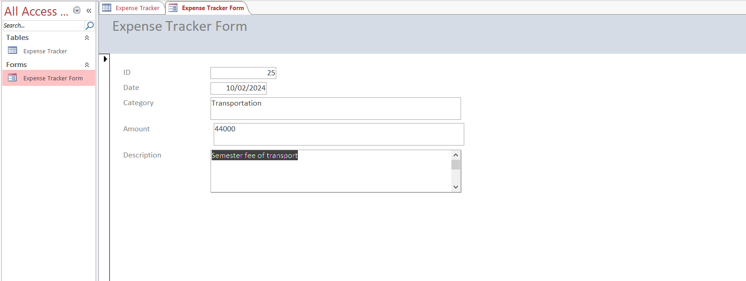

**2. Add at least 25 different records to the table.**

**3. Save the form with appropriate name.**

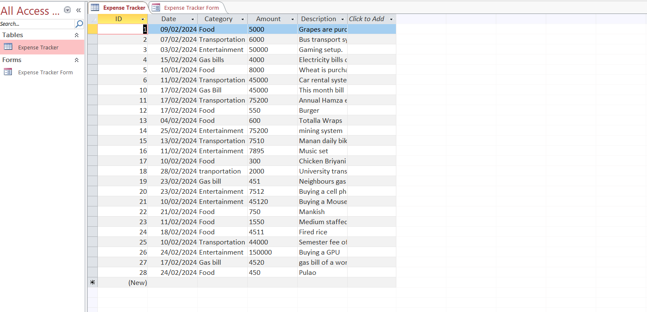

**Task no 3:**

**1. Implement a SELECT query to display all expenses entered by the user.**

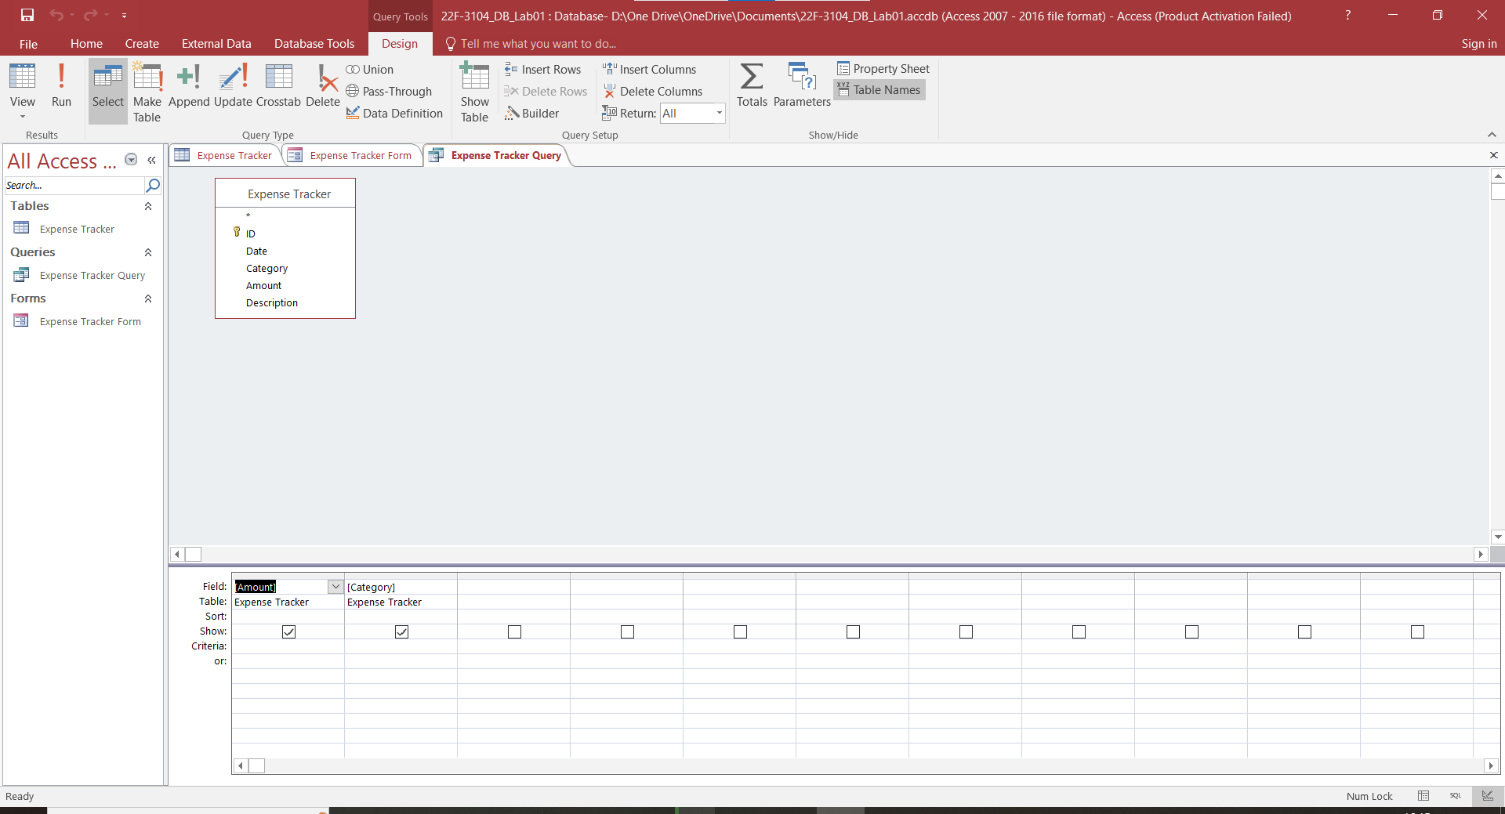

**2. Implement functionality to filter and display expenses by category/amount (e.g., display**

**all expenses of amount greater than 10,000).**

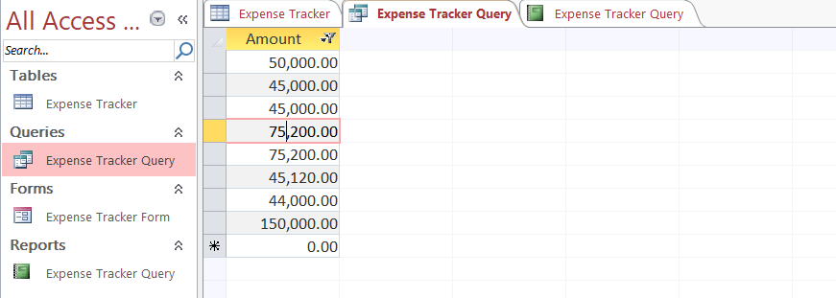

**a. Display relevant query result in a readable report format.**

**3. Save the query and report with appropriate name.**

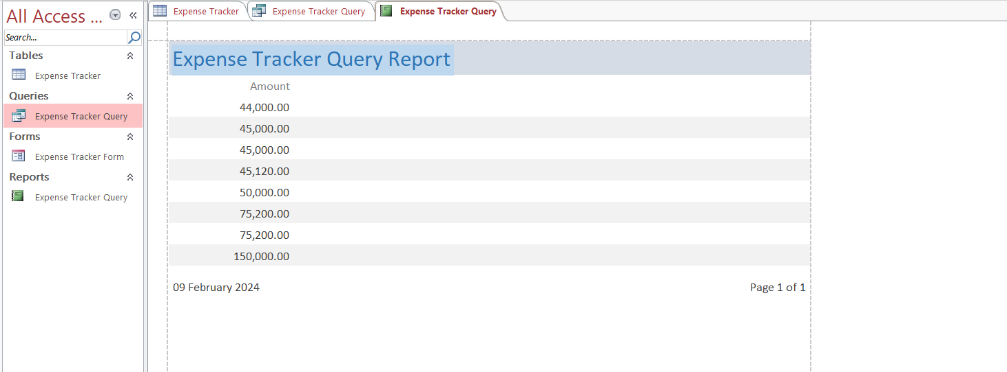

**Task no 4:**

**1. Implement an UPDATE query that allows users to update the details of existing**

**expenses (e.g., amount, category).**

**a. Ensure that updates are validated and handled properly.**

**2. Save the query with appropriate name.**

**Before Updating:**

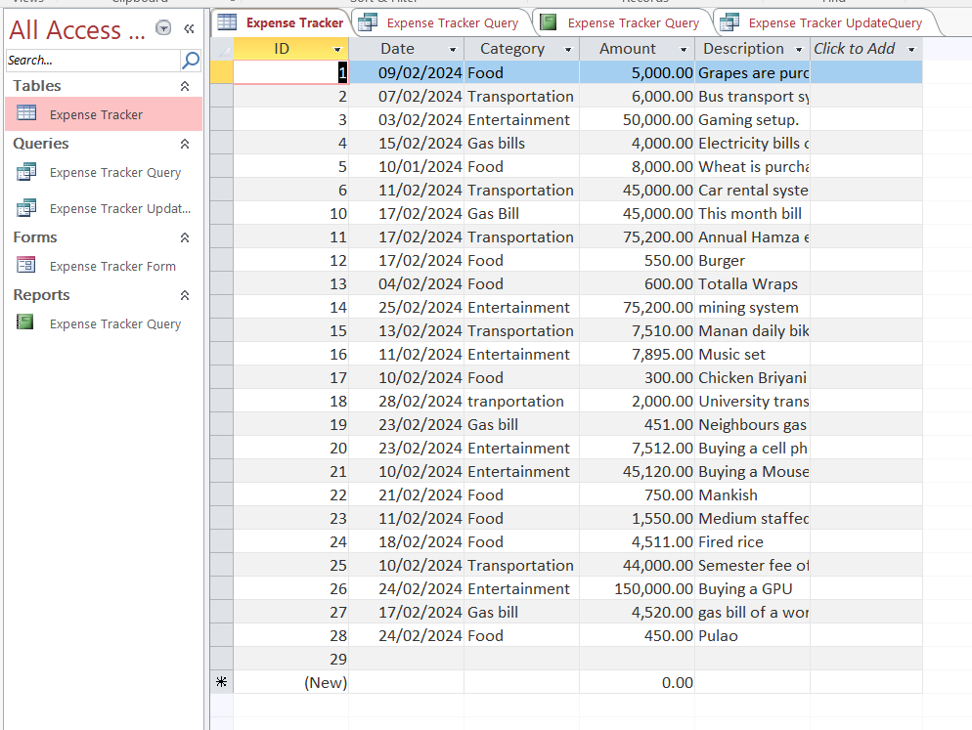

**Performing Updating:**

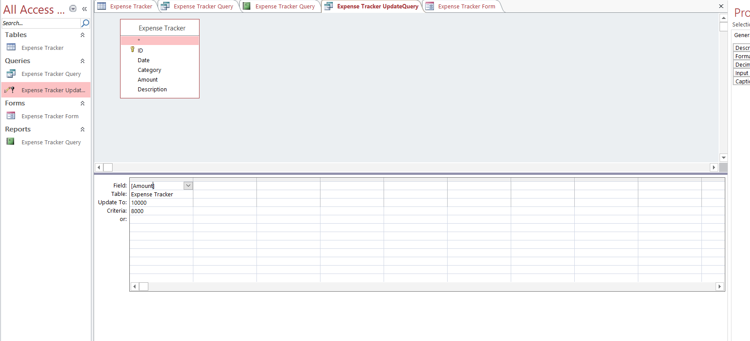

**After Updating:**

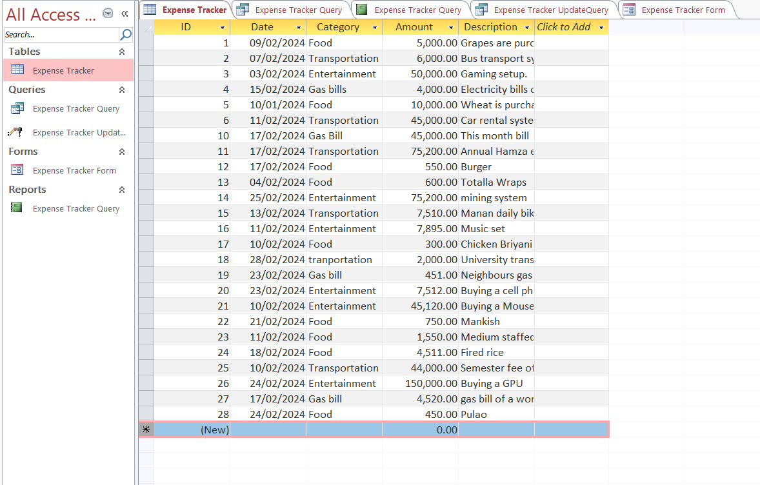

**Task no 5:**

**1. Implement a DELETE query to remove expenses from the table.**

**a. E.g. remove the expenses of “transport” category from the table.**

**2. Save the query with appropriate name.**

**Before Deletion:**

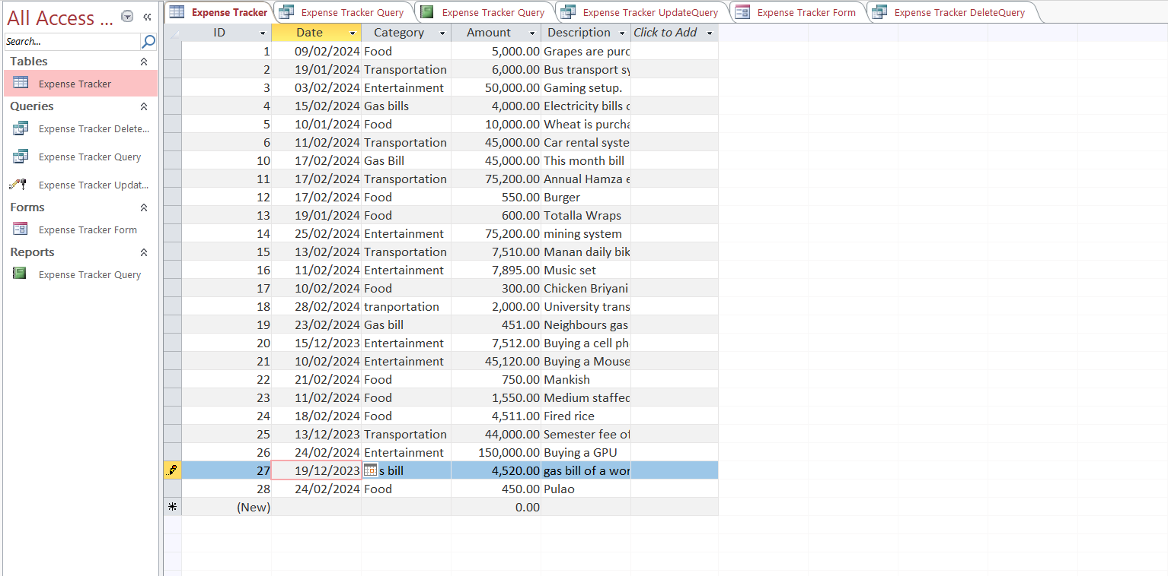

**After Deletion:**

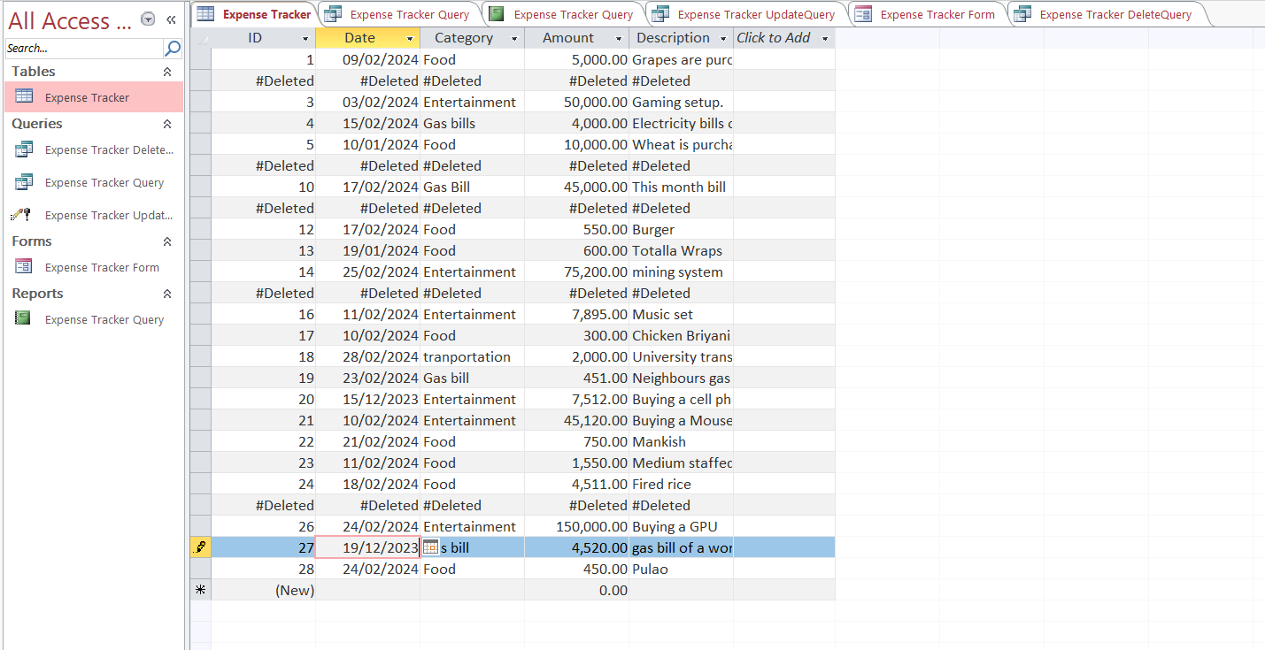

**Task no 6:**

**1. Create following expense reports, such as:**

**a. Monthly expense report**

**i. Calculate and display the total expenses for that month, broken down by**

**category.**

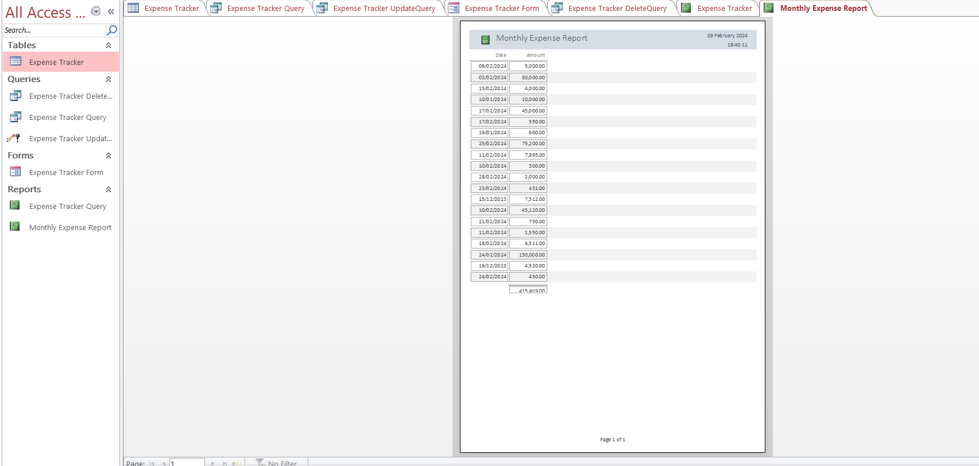

**2. Export report in excel file.**

**3. Save the report with appropriate name.**

